NUKO December 2021 Newsletter
December is upon us! The students and staff are feeling the excitement of the upcoming holidays and can use the much needed break.
This month we are welcoming 2 new practicum students from Sprott Shaw who will be helping out in the classrooms and offering much needed 1:1 support for students.
We have also had some new staff join our team. We welcome you to go to our website and become familiar with the new faces
With the unpredictable Nanaimo weather, we just want to remind parents that if we get snow and have to close the centre, that information will be posted on our Facebook page by 7:30 and any closures for SD#68 will be on the local radio station. There may be times however that NUKO is closed when schools are open.
We do salt our sidewalks once things get more slippery but please be aware that the gutter at the corner of our building by the parking lot leaks, and so that area may be slicker than others. Please use caution.
A reminder that NUKO has enrolled into Country Grocers great program called “Save a Tape”. NUKO will receive 1% back on a gift card for every dollar you spend. The gift card will be used to purchase items for events we do with the students and to cover the cost of some items we need for science experiments. Receipts need to be given to NUKO so we can submit them along with the tracking sheet.
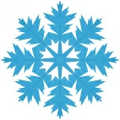
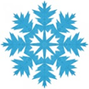

December
December Birthdays
4- Finlay
11- Carter
14- Reese
16- Donald
25- Matty
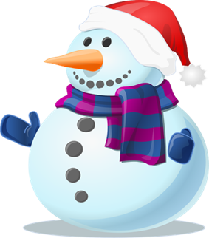

Important dates:
December 17- Last day of classes
December 18-January 3-Centre closed for winter break
January 4- Centre re opens, classes resume

