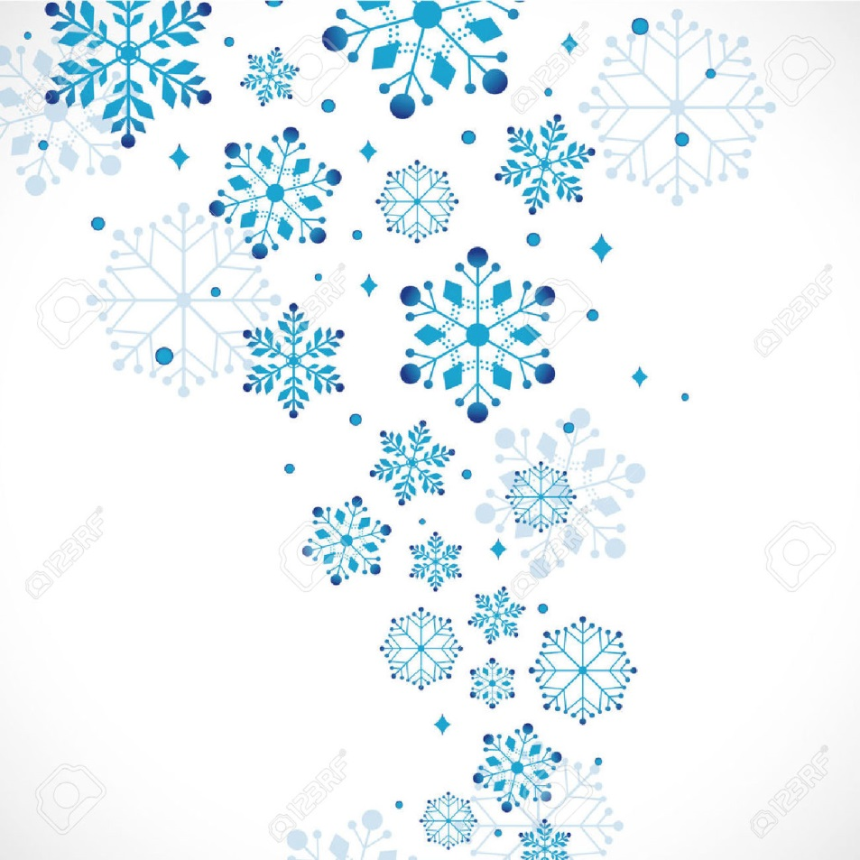

NUKO January 2022 Newsletter
Happy New Year!

We hope that you all had a safe and happy holiday. Welcome 2022!
This month will be focused on getting students back into routine after having time off.
We know that they have been busy enjoying their presents, but please remind them not to bring any toys/items from home into the centre.
Please continue to monitor your kiddos for signs of sickness. Due to the rising COVID cases we ask parents to be extra vigilant and please to not send students to school with any sign of sickness (Fever, runny or stuffy nose, cough, sore throat, etc.) Also if anyone in the household is showing signs of sickness, again please do not send your child.
Parents will be phoned and asked to pick up their child in a timely matter if they do present as unwell.
Due to the success of spirit wear, Masja will be placing another small order in the coming weeks. If you missed out or would like more items, please email her directly to place an order or to inquire about pricing, etc at nukostaff@nuko.ca
On days that the weather is friendly, students will be spending time at the end of the day in the playground. We ask that parents pick their child up from the playground directly to ease with transitions. Playground days are as follows: Cody’s class- Tuesdays, Kathy’s class-Wednesdays, Katlyn’s class- Thursdays & Kipp’s class Fridays. If in doubt due to weather, check with Samantha at the front door
For the months of December & January, Steve Marshall Ford Lincoln has chosen to donate $100 of every vehicle sold directly to NUKO. We are so thankful to Ford for being so supportive in the community and choosing NUKO as their charity of choice this year. If you are in the market for a new vehicle, please do stop by and see Troy Harder, who is a member of our NUKO family
With the changes recently due to COVID and for any other important information, we remind parents to please like and follow our Facebook page, if they haven’t already.
●●●
Weather:
It’s that time of year again when the weather can turn quickly and we can get snow. When/if the snow starts to stick on the ground, and if there is a centre closure, we will try and have that information posted on the Facebook page by 7:30am and hopefully on the local radio station. If SD #68 is closed due to weather NUKO WILL also be closed as well. Reminder that there may be times that NUKO will be closed due to weather when the SD is open. Please check the FB page for updates.
●●●

