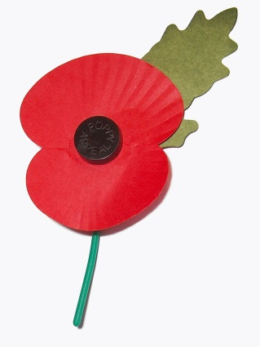

**NUKO November 2021 Newsletter**

Happy November! We have found our groove and everyone seems to have settled in and making great strides here at the centre.

A reminder that this Wednesday, November 3 is photo day.

NUKO is very excited to welcome back to the team, Keri Chapdelaine! Keri officially joined the NUKO team as our own Behaviour Analyst this month, and we are so thrilled to have her on board. She will be working in the centre throughout the week, so feel free and say hi when you see her around ☺

For any families who have not yet returned sold & unsold tickets, please do so as soon as possible. The deadline is today, November 1st, as the draw date is November 9 at 6pm at our annual general meeting.

We have also sent home order forms for any families interested in spirit wear items. We are happy to be supporting Top Drawer Graphics right here in Nanaimo. If you are interested in purchasing items, please have your forms in by November 12, as we are hoping that this gives us enough time to have orders back before Christmas break, although there is no guarantee.

November 19 is Pj & Sundae day at the centre. Kids are encouraged to wear their pj’s to school and we will be giving the kids ice cream & choice of toppings to create their own Sundaes ☺

Weather:

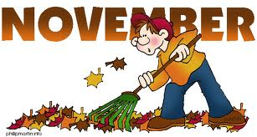It’s that time of year again when the weather can turn quickly and we can get snow. If there is a centre closure we will try and have that information posted on the Facebook page by 7:30am and hopefully on the local radio station. If SD #68 is closed due to weather NUKO WILL also be closed as well. Reminder that there may be times that NUKO with be closed due to weather when the SD is open or vice versa. Please check our FB page for updates.

November Birthdays 

**November 1- Wyatt  
 November 2- Shauna  
 November 7- Riley**

**Important dates:**

**November 3- Picture Day**

**November 11- Remembrance day, centre closed  
  
November 9- AGM meeting. Further info will be posted on our Facebook page  
  
November 19- PJ & Sunday day ☺**