NUKO May 2021 Newsletter
May!? How did that happen? Can you believe we are almost done the school year? Time has flown by. Bring on the sunshine!!
A reminder that this Friday is a Pro-D day and NUKO’s learning centre will be closed. Intervention is still on.
All the staff and students would like to send out a big thank you for all the support the centre has received in the past few months. Every little bit helps and we have been able to buy more equipment for our movement area that the kids love. We truly appreciate all the support and help that our community.
has provided.
A reminder that if any families do shopping at Cobs bakery we encourage you to mention NUKO at either location during the time of purchase. We will receive 5% back of all sales at the end of each fiscal year in June.

Important dates:
May 4 & 5- Kerri Isham
May 7- Pro D day- NUKO closed
May 9- Mother’ day
May 11- NIDES OT visiting centre
May 24- Victoria day- NUKO closed

We have set up a Scholastic account for the convenience of parents to order books for their child. NUKO will receive 20% of the value for each order purchased; be sure to enter the My Class Code RC590466 online at the time of ordering.
By now IEP notices should have been sent home and returned with a signature. We hope that parents/caregivers are able to attend. If you have not received a notice, please contact the centre. If you have not yet sent the notice back indicating whether you will be attending or not, we ask that it is returned as soon as possible. If you require a reminder about what day your child’s IEP is on, or for more information please email Sam.
We are also excited to announce that we have received baby chicks! They are still currently incubating and the kids have been having fun keeping an eye on them and recording any changes. It has been great for learning about the life cycles and creating hypothesis’ on when they think they will hatch. All classrooms have also had the chance to come up with names! The eggs are scheduled to hatch in the next week and a half or so so egg-citing!!
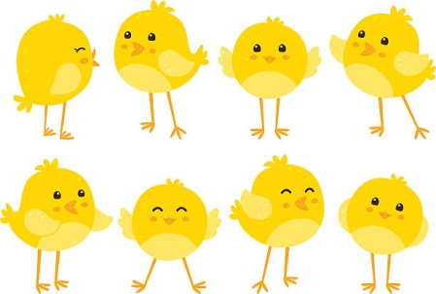
May Birthdays
Asher- May 6
Cedric- May 20

